

INTERIM REPORT ON THE ACTIVITIES OF BILLBOARD AD DURING THE
FIRST QUARTER OF 2016 PURSUANT TO
Article 100o, Paragraph 4, Item 2 of LPOS

- IMPORTANT DEVELOPMENTS FOR BILLBOARD AD THAT OCCURRED DURING THE FIRST QUARTER OF 2015 (01.01.2016– 31.03.2016)

On 01.02.2016 BILLBOARD AD filed with FSC and BSE-Sofia AD and presented to the public interim individual financial report for the fourth quarter of 2015.

On 26.02.2016 BILLBOARD AD filed with FSC and BSE-Sofia AD and presented to the public interim consolidated financial report for the fourth quarter of 2015.

On 29.03.2016 BILLBOARD AD filed with FSC and BSE-Sofia AD and presented to the public Annual audited separate financial statements as of 31.12.2015.

  - IMPORTANT DEVELOPMENTS FOR BILLBOARD AD THAT OCCURRED FROM THE BEGINNING OF THE FINANCIAL YEAR TO THE END OF THE FIRST QUARTER OF 2016 WITH ACCUMULATION

On 01.02.2016 BILLBOARD AD filed with FSC and BSE-Sofia AD and presented to the public interim individual financial report for the fourth quarter of 2015.

On 26.02.2016 BILLBOARD AD filed with FSC and BSE-Sofia AD and presented to the public interim consolidated financial report for the fourth quarter of 2015.

On 29.03.2016 BILLBOARD AD filed with FSC and BSE-Sofia AD and presented to the public Annual audited separate financial statements as of 31.12.2015.

3. IMPACT OF THE IMPORTANT DEVELOPMENTS FOR BILLBOARD AD THAT OCCURRED DURING THE FIRST QUARTER OF 2016 ON THE RESULTS IN THE FINANCIAL STATEMENT

BILLBOARD AD is a company with the following scope of activity: foreign and domestic trade; specific trade operations; barter and cross transactions; sales under the conditions of letters of credit; export of Bulgarian products to the international market; distribution of great volumes of imported goods; commercial representation; intermediation between local and foreign parties; printing and wide format printing activities; advertising activity; acquisition and incorporation of new companies with a scope of activity – printing, wide format printing activities, advertising activity as well as sale of such companies; acquisition, management, evaluation and sale of share participations in Bulgarian and foreign companies; acquisition, evaluation and sale of patents; transfer of licenses for use of patents to companies where the company participates; financing of companies where the company participates.

BILLBOARD AD and the companies included in the economic group perform activities in the following major spheres:

- Digital wide format printing;
- Offset printing;
- Construction and maintenance of advertising equipment;
- Information technologies and professional solutions for digital printing;
- Design and construction of integrated management information systems in the field of printing and advertising business;
- Complex solutions in the field of outdoor and interior advertising.
In the field of outdoor advertising BILLBOARD AD develops and offers various types of billboards, mega boards, City Lights, advertising shop windows, awnings, facade advertising with integrated lighting and unlighted facade advertisement banners and packing of buildings.

In the field of indoor advertising BILLBOARD AD develops and offers printing of posters and banners with photo quality, including 3D posters, illuminated advertisements, banners, floor graphics, design and implementation of various backdrops, branding, development of boards and panels, models of objects and people in natural size, advertising on custom interior spaces, expo systems.
In the field of transport advertising BILLBOARD Plc develops and offers a variety of services in the field of branding for different types of vehicles - cars and trucks, airplanes, ships and boats, means of public transportation.
In carrying out its activities in the different fields BILLBOARD AD uses various technologies, such as:
- solvent printing - characterized by high resistance to external conditions and suitable for the production of outdoor advertising with high resistance. BILLBOARD AD has the most modern equipment for digital wide format solvent printing with almost all models of the brand Vutek - a world leader in the field as all of them are the latest generation of 8-color models.Also, the printing base is equipped with a HP Turbojet 8530 machine, which is unique for its kind.
- ink-jet printing – the technologies for digital wide format printing on a water base are of high quality and are used for printing on paper. BILLBOARD AD has the latest models of the brand HP Designjet which manifest extremely high quality, reliability and fast performance. The company participated as a co-organizer in many exhibitions.
- UV printing - the most advanced technology in printing with liquid polymer inks, cured by irradiation with UV light. Instant drying of the inks enables this technology to be used for direct printing on all materials. The printing quality is very high in color mode, which enables displacing the screen printing technologies.
- textile printing – the Dye Sublimation technology is the basis for dyeing in textile industry. With the development of digital technologies, the classic method of printing is being displaced by direct printing with sublimation inks and non-standard sizes and formats.
- 3D printing - the development of digital printing opens up new possibilities for production of 3D models applicable both in the art field and in the field of industrial design, architecture, etc. New technologies facilitate and expedite the process in modeling, which is already been implemented entirely by using computer systems, 3D modeling softwares and make it much more accessible for implementation.
- multimedia screens - development of digital technologies increasingly leads to imposition of multimedia screens as a means of visual communication with consumers in interior environments. Through them, static images are being developed in an interactive multimedia environment which creates a dynamic atmosphere and enhances the effect of advertising.
- In addition to the aforementioned technologies BILLBOARD AD has all the necessary equipment needed for cutting the printed output or finished color and for performing all finishing works such as sewing and gluing, laminating and laminating, routing and milling.

Table № 1
Indicators | Description | Value
Average price per share as at 31.03.2016 |  | BGN 0.499
Book value per share | Shareholders equity / Number of issued shares | BGN 1.397
Market capitalization of BILLBOARD AD as at 31.03.2016 | Market price * Number of issued shares | BGN 7 485 000
P/BV (Price book value) |  | BGN 1,39
P/S (Price sales) |  | BGN 0.11
P/E (Price earnings) |  | 0,08

Pursuant to the unaudited individual financial statements of BILLBOARD AD, drawn up according to the IFRS/IAS forms, as at 31.03.2016 the company reported total individual net sales revenues in the amount of BGN 1 712 000 compared to BGN 1 682 000 for the same period of 2015 which represents an increase of the net sales revenues by 1,78 %. As at 31.03.2016 the individual production net sales revenues of BILLBOARD AD were in the amount of BGN 1 538 000 compared to the individual production net sales revenues reported by 31.03.2015 in the amount of BGN 1 429 000. This represents an increase of the company’s production net sales revenues on an individual basis by 7,62 %.
As at 31.03.2016 BILLBOARD AD reported on an individual basis profit before taxes in the amount of BGN 5 000 compared to the loss before taxes for the same period of 2015 which is in the amount of BGN 32 000.
The individual net profit of BILLBOARD AD as at 31.03.2016 is in the amount of BGN 12 000 compared to the individual net loss of the Company as at 31.03.2015 in the amount of BGN 26 000.
As at 31.03.2016 the earnings before taxes and depreciation and amortization, increased by the financial expenses and decreased by the financial incomes of the BILBOARD AD on an individual basis were to the amount of BGN 406 000 compared to EBITDA as at 31.03.2015 to the amount of BGN 449 000.
As at 31.03.2016 the earnings before taxes, increased by the financial expenses and decreased by the financial incomes (EBIT) of BILBOARD AD on an individual basis were in the amount of BGN 102 000 compared to EBIT in the amount of BGN 143 000 as at 31.03.2015.

4. DESCRIPTION OF THE PRINCIPAL RISKS AND UNCERTAINTIES WHICH BILLBOARD AD WILL FACE DURING THE FOLLOWING FINANCIAL PERIOD

SYSTEMATIC RISKS

OVERALL MACROECONOMIC RISK

Pursuant to data of the National Statistical Institute in March 2016 the total business climate indicator increased by 1.6 points compared to the previous month which is due to the more favorable opinions of managers in industry, construction and retail tradе.

Business climate – in total
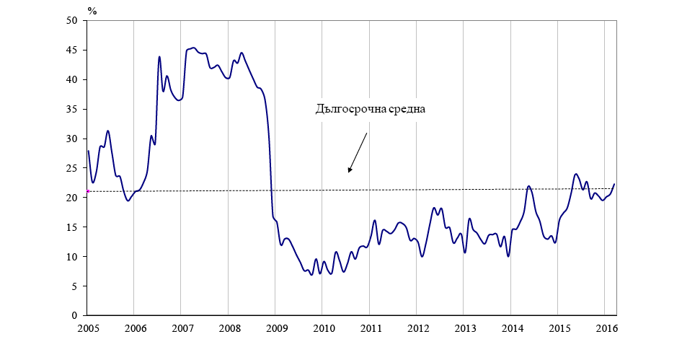

Source: NSI

Pursuant to data of the National Statistical Institute the composite "business climate in industry" indicator increased by 2.9 points compared to February 2016 due to the more optimistic assessments and expectations of industrial entrepreneurs about the business situation of enterprises. Current production activity, however, is estimated to be slightly reduced, and the expectations for the activity over the next three months are more reserved.
Main obstacles for the business development in the sector continue to be related to the uncertain economic environment and the insufficient domestic demand, indicated respectively from 54.8 and 29.8 % of the enterprises. Concerning the selling prices in industry managers foresee no change over the next three months.

Expected business situation in industry during the next 6 months

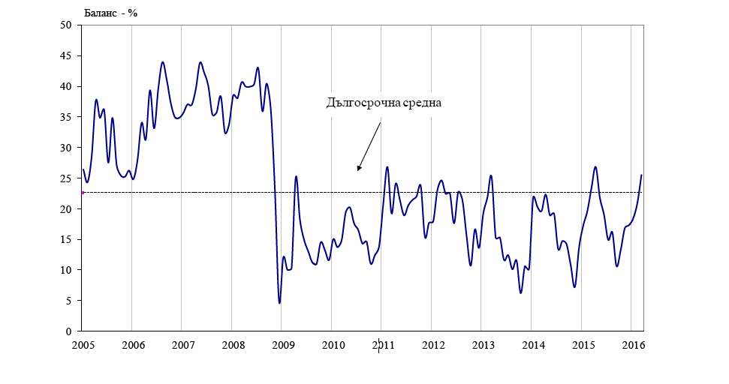

Source: NSI

According to NSI in March 2016 the composite "business climate in construction" indicator increased by 2.4 percentage points due to the favorable assessments of construction entrepreneurs about the current business situation of enterprises. In their view, this construction activity has improved compared to the previous month and their forecast for the next three months remains optimistic.
The factor impeding to the greatest extent the activity in the sector remains the uncertain economic environment. Second and third place are taken by the competition in the industry and the insufficient demand.
As regards the selling prices in construction the majority of managers expect that over the next three months their levels will remain unchanged.
Pursuant to data of the National Statistical Institute in March 2016 the composite "business climate in retail trade" indicator increased by 1.0 percentage points compared to February 2016 as a result of more favorable expectations of retailers about the business situation of enterprises over the next six months. At the same time their forecasts about sales volumes and orders placed with suppliers over the next three months are improving. The most serious problem for development of the activity in the sector continues to be related to the competition in the sector.
Based on information of the National Statistical Institute in March 2016 the composite "business climate in the services sector" indicator decreased by 1.3 percentage points due to the more moderate assessments and managers expectations about the business situation of enterprises. With regard to the current demand for services their opinions were more reserved, while their expectations for the next three months remained favorable.

INTEREST RATE RISK

The interest rate risk is related to possible, contingent adverse changes in the interest rates, set by the financial institutions in the Republic of Bulgaria.
In February 2016 the ECB decided to give new incentives for the financial sector. On 10.03.2016 the Governing Council of the ECB passed the following resolutions:
- The base interest rate for refinancing of commercial banks was changed to 0 %. The effect of this decision is rather symbolic since so far the interest rate was 0.05 %.
- The deposit interest rate was changed to -0.4 % which means that in order to deposit their excess funds at the moment with the ECB commercial banks will have to pay more. The purpose is for banks to increase lending thereby supporting economic growth.
- Incentives for lending - the ECB will offer banks loans at 0 % interest rate over the next four years. Moreover, the interest rate can become negative reaching -0.4 % if banks offer lending to the business. This means that the ECB will actually pay commercial banks to receive lending from ECB.
- The program for the purchase of corporate debt increased from EUR 60 to 80 billion per month. The purpose is fresh cash to start flowing in economy thus allowing the targets for inflation in the Eurozone to be pursued.
Despite all these attempts to stimulate inflation, the forecast of the ECB is that at least until 2018 the target inflation of 2 percent will not be achieved. For the next year the bank's economists expect inflation of 1.3 percent and 1.6 percent. In the forecasts for economic growth numbers are also quite low - 1.7 and 1.8 percent for 2017 and 2018.

Base interest rates set by the Bulgarian National Bank for the period
01.01.2016 – 31.03.2016:

Table № 2
Month | Base Interest Rate
January 2016 | 0.01 %
February 2016 | 0.00 %
March 2016 | 0.00 %
*Source:BNB

INFLATION RISK

Inflation risk is the overall increase in prices, where money is devalued and there is likelihood for households and businesses to suffer losses.
Pursuant to data of the National Statistical Institute the consumer price index for January 2016 compared to December 2015 was 100.0 %, i.e. monthly inflation is 0.0 %. The annual inflation for January 2016 compared to January 2015 is 0.0 %. The average annual inflation for the period February 2015 – January 2016 compared to the period February 2014 – January 2015 is 0.0 %.
Pursuant to data of the National Statistical Institute the harmonized consumer price index for January 2016 compared to December 2015 was 99.8 %, i.e. monthly inflation is minus 0.2 %. The annual inflation for January 2016 compared to January 2015 is minus 0.3 %. The average annual inflation for the period February 2015 – January 2016 compared to the period February 2014 – January 2015 is minus 0.9 %.
The consumer price index for February 2016 compared to January 2016 was 99.7 %, i.e. monthly inflation is minus 0.3 %. Inflation from the beginning of the year (February 2016 compared to December 2015) is minus 0.3 % and the annual inflation for February 2016 compared to February 2015 is minus 0.5 %. The average annual inflation for the period March 2015 – February 2016 compared to the period March 2014 – February 2015 is 0.0 %.
The harmonized consumer price index for February 2016 compared to January 2016 was 99.5 %, i.e. monthly inflation is minus 0.5 %. Inflation from the beginning of the year (February 2016 compared to December 2015) is minus 0.7 and the annual inflation for February 2016 compared to February 2015 is minus 1.0 %. The average annual inflation for the period March 2015 – February 2016 compared to the period March 2014 – February 2015 is minus 0.8 %.
The consumer price index in March 2016 compared to February 2016 was 99.3 %, i.e. the monthly inflation was -0.7 %. The inflation rate since the beginning of the year (March 2016 compared to December 2015) has been -1.0 % and the annual inflation in March 2016 compared to March 2015 was -1.5 %. The annual average inflation for the period April 2015 - March 2016 compared to the period April 2014 - March 2015 was -0.2 %.
The harmonized consumer price index in March 2016 compared to February 2016 was 99.4 %, i.e. the monthly inflation was -0.6 %. The inflation rate since the beginning of the year (March 2016 compared to December 2015) has been -1.3 % and the annual inflation in March 2016 compared to March 2015 was -1.9 %.
The annual average inflation for the period April 2015 - March 2016 compared to the period April 2014 - March 2015 was -0.9 %.

Inflation for the period 01.01.2016 – 31.03.2016 is as follows:
Table № 3
Month | % of inflation
January 2016 | 0.00 %
February 2016 | - 0.3 %
March 2016 | -0.7 %

*Source:NSI

POLITICAL RISK

Political risk is the likelihood of a governmental change or a sudden shift in its policy, occurrence of external or internal political disturbances and unfavorable changes in the European and/or national legislation, as a result of which the environment where local businesses operate to change adversely and investors - to suffer losses.
Political risks for Bulgaria in the international aspect are associated with the commitments for implementation of significant structural reforms in the country in its capacity of a full-right EU member, enhancing social stability and reducing inefficient expenses.
The Country Report Bulgaria of the European Commission, dated 26.02.2016 makes an in-depth review of all sectors and some of the main findings and forthcoming policy challenges for the country are indicated to be:
• The performance of the financial sector as a whole has stabilised, but risks remain. It is found that the banking sector liquidity and profitability has improved, but it is also indicated that a more robust assessment of the resilience of the sector can only be made based on the results of the upcoming asset quality review and stress test, which are expected towards late summer. Vulnerabilities in the non-banking sector have been identified that have yet to be addressed.
• Risks stemming from high corporate debt and barriers to deleveraging remain. The persistent negative inflation makes deleveraging more difficult and puts additional pressure on the profitability of non-financial corporations.
• The external position of the country as a whole has improved further but risks remain.
• Remaining weaknesses in the labour market continue to hinder growth and limit the adjustment capacity of the economy. It is noted that despite progress with reforms of active labour market policies, further improvement in matching people with vacancies is hindered by poor prioritisation, targeting and sustainability of measures in this area.
Bulgaria together with the other countries – EU members from the region continue being seriously affected by the common European problem with the intensive refugee flow from the Middle East.
Political risk will continue growing if the government fails to take adequate measures for consistent implementation and completion of the structural reforms in all sectors and implement an integrated policy for financial, economic and social stabilization of the country.
Other factors that also influence this risk are possible legislative changes and in particular those concerning the economic and investment climate in the country.

CURRENCY RISK
Exposure to currency risk is the dependence on and the effects from changes in the currency exchange rates. Systematic currency risk is the likelihood of any possible change of the currency regime in the country (currency board) which would either lead to devaluation of the BGN or the appreciation of the BGN against foreign currencies.

Currency risk will have impact over companies having market shares, payments to which are made in currencies different from the Bulgarian lev and the euro. In view of the fact that according to the current legislation in the country the Bulgarian lev is pegged to the euro at the rate of EUR 1 = BGN 1.95583 and the Bulgarian National Bank is obliged to maintain a level of Bulgarian lev in circulation equivalent to the foreign exchange reserves of the Bank, the risk of devaluation of the lev against the European currency is minimal and consists in a possible elimination of the currency board in Bulgaria ahead of term. At this stage it appears to be unlikely since the Currency Board is expected to be repealed upon adoption of the euro as an official legal tender in Bulgaria.
Theoretically, currency risk could increase when Bulgaria joins the second phase of the European Exchange Rate Mechanism (ERM II). This is a regime under which the country must maintain the currency rate against the euro within a + / -15% from central parity. In practice, all countries which are currently in the mechanism (Denmark, Estonia, Cyprus, Lithuania, Latvia, Malta) have witnessed fluctuations that were significantly smaller than the allowed ± 15%.
The fixed rate of the BGN to the EUR does not eliminate the risk for the Bulgarian currency of adverse movements in the euro exchange rate against other major currencies (U.S. dollar, British pound, Swiss franc) in the international financial markets, but at present the company does not consider that this risk would be significant in terms of its activity. The company might be affected by the currency risk, depending on the type of currency of its cash and the type of currency of the company’s contingent loans.

LIQUIDITY RISK

The appearance of liquidity risk with regard to the company is being associated with the possible lack of timely and/or sufficient cash to meet all current liabilities. This risk may occur, either in case of significant delays in payments from debtors of the company, or in case of insufficiently effective management of the company’s cash flows.

UNSYSTEMATIC

SECTOR RISK
As a result of the impact of the economic crisis the advertising and printing industry in Bulgaria faced serious problems - decreased demand, increased share of lower quality but, at the same time, cheaper printed materials and services, and even outflow of clients. Most sectors of the economy, that suffer the effects of the economic crisis most essentially, reduced their advertising costs, which also had an impact on the activity of a number of graphic and advertising studios and printing houses, respectively.
BILLBOARD AD is dependent mostly on the general trends in the field of printing, marketing and advertising. Since the amount of investments in marketing depends on the amount and allocation in time of the cash flows of the client itself and the overall situation of the sector where the advertiser operates, BILLBOARD AD is directly dependent on the cyclicity of the economy. Slowdown of the Bulgarian economy growth and reducing the cost of advertising and printing, respectively, may have a major negative impact on the company’s revenues and profit.
This risk is somewhat compensated by the extensive production capabilities and know-how that would allow BILLBOARD AD quickly redirect to new demand of products and services in the event of change in the demands’ structure.
Advantage to the company is also the new and modern technological equipment which give BILLBOARD AD the opportunity to realize production of very high quality. In practice, in this respect, the range of competitors of BILLBOARD AD on the territory of the country that have the technical and technological capacity to produce printed products of such quality, is very limited. Further advantages are the finally entered into service high tech printing line in Varna, which is expected to expand the market presence of BILLBOARD AD and the companies in the group both outside the territory of Bulgaria and on the local market, and the serious increase of the metro advertising volume as a result of the final completion and put into operation of the first diameter of the Sofia Underground.

RISK OF INTRODUCTION OF NEW TECHNOLOGIES

BILLBOARD AD is in a permanent process of investing in new equipment, which ensures that the production is in line with the technological processes development trends. Practice has shown that more substantial changes in the technologies used in the sector does not occur in less than 5 years as older technologies are not fully replaced by the new ones. This enables gradual integration of new technologies when such technologies appear.
Regarding the risk of introduction of other, already existing, but not applied in Bulgaria, printing technologies, such as rotogravure, it should be noted that in order for such technologies to become cost-effective it is required much larger volumes of the single orders, which determines the different application field of these technologies, and the fact that they are not particularly competitive in the segments where the company operates.

- INFORMATION ABOUT THE CONCLUDED LARGE TRANSACTIONS WITH RELATED PARTIES DURING THE FIRST QUARTER OF 2016

During the first quarter of 2016 were concluded the following large transactions with related parties to BILLBOARD AD which were also a part of the economic group:

Table № 4
Related party | Type of relation | Volume of the transactions, in BGN thousand | Explanatory notes
DEDRAX AD | subsidiary where BILLBOARD AD holds 60 % of the capital | 199 | Printing production, rentals, fixed assets etc.
MOTION ARTS Ltd. | subsidiary where BILLBOARD AD holds 51 % of the capital | 115 | Printing production, rentals, fixed assets etc.

Transactions with related parties were executed under fare market values.

20.04.2016 For BILLBOARD AD:………………………..
Sofia Stefan Genchev
/Executive Director/

